Jeff Wallhermfechel

CPSC 430 Usability Study - Individual Assignment

**1.**

1. Becky Cantaloupe is a stay at home mom with three kids. While her kids are in school, she spends most of her free time working from home as a part-time sales-representative for a paper supply company. She finds the house eerie when she is home alone because it is too quiet, so she often leaves the TV on most of the day. She likes the TV because it is easy to adjust the volume when she needs to focus or receives a phone call. Every day the TV inevitably drags her out of her office and onto the couch as she brainlessly waits for the all-day news to cover their fluff piece on why there will be a shortage of watermelons this summer. Becky wants to find a source of background noise that won’t distract her as easily, but doesn’t compromise her control of the auditory air space. This is why Becky listens to B101.5 through her amazon echo.
2. Jack Honeydew is a young man who lives alone with his dog, Gus. Most of Jack’s hobbies are hands-on, leaving his mind and ears idle. Seeing as Gus only appears to be able to communicate with squirrels, Jack listens to podcasts throughout most of his day. He has found that one of his favorite podcast is B101.5’s *The Outcast*. Jack’s house rigged up with an echo in every room, so he can listen to podcasts anywhere. He listens to them when he’s knitting in the living room, when he’s doing dishes in the kitchen, and when he’s eating watermelon in the dining room.
3. David Canary is a 62-year-old man who has lived in Fredericksburg his whole life. David has enjoyed listening to *News Talk 1230* every day, as he gets ready for work. Now that he and his wife, Rebecca, are retiring to Florida, he is worried that he will not be able to find a talk radio that meets his standards. Understanding this dilemma his daughter, Jane, bought him an Amazon echo. She showed him how to activate the *News Talk 1230* skill, and now he can continue to listen to it every morning before he gets up to water his watermelons.

**2.**

My software’s overall function is to bring Centennial Broadcasting’s content to Amazon Alexa enabled devices. The final product will consist of two different skills, B101.5 and NewsTalk1230. Both products will be able to play their respective radio steams as well as Centennial Broadcasting’s newest addition, podcasts. There will several different podcast channels to choose from, and users will be able to select a specific episode from each channel. The software will also implement basic playback controls such as: pause/play and volume up/down.

Function – play a specific podcast

Person 1

How will you interact with the echo to make it play a podcast?

*Start the skill, say “Alexa, play episode (x) of (podcast name)*

What should you be able to do with the skill?

*Play an episode of my choice.*

What shouldn’t the skill be able to do?

Play something inappropriate, or something I didn’t ask for.

Person 2

How will you interact with the echo to make it play a podcast?

*Start the skill, and ask “Alexa give me a list of podcasts”. To which Alexa would respond with A,B, and C. Then I would say “Alexa, play* podcast C”

What should you be able to do with the skill?

*Play music/podcasts*

What shouldn’t the skill be able to do?

*Users should not be able to fast forward through commercials.*

Person 3

How will you interact with the echo to make it play a podcast?

*Start the skill, and say “Alexa play podcast (x), from yesterday”*

What should you be able to do with the skill?

*Find the podcast I want, pause, resume, skip ahead (time), go back (time).*

What shouldn’t the skill be able to do?

*“Cook me breakfast”*

Person 4

How will you interact with the echo to make it play a podcast?

*Start the skill, and say “Alexa play podcast (x) episode (y)”*

What should you be able to do with the skill?

*Have the skill remember what episode of a podcasts I’m on, or where in an episode I am.*

What shouldn’t the skill be able to do?

*Play other radio stations/podcasts.*

Summary:

Users will be able to activate the skill by saying “Alexa, start B101.5” or “Alexa, start NewsTalk1230”, and the echo will begin playing the radio. To access podcasts, users should be able to specify podcasts by name or name-and-episode. If the user doesn’t know what Podcast they want to hear, they should be able to ask Alexa for help.

**3.**

User Interface:

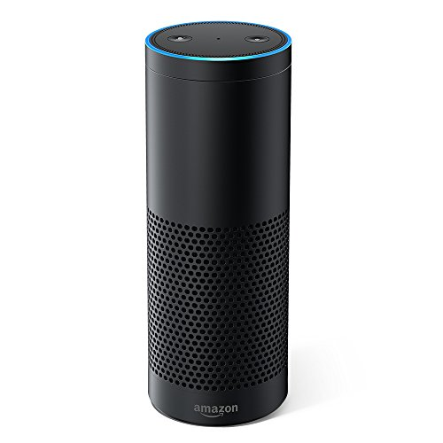

**User Alexa**

“Alexa, Start B101.5”

*Starts Playing Radio Stream*

“Alexa, Help”

“You can ask me to play different podcasts.

Try asking me to play Episode 1 of *The Outcast*

4. Seeing as Alexa doesn’t have a useful visual interface, I gave my focus group the example help menu (above), and asked them how they would use the skill from there.

Person 1:

No change in how they would use it. Jus ask Alexa to “play [name of podcast] [*episode* and number]”, but the episode number is optional

Person 2:

Would follow the example given in the help menu, and would like more Information. Want to know if they can turn up the volume, pause, etc.

Person 3:

Want the help menu to be contextual to where they are in the skill. If they are listening to radio, they want one help menu. If they are selecting a podcast, they want a different help menu. If they are listening to a podcast they want another help menu.

Person 4:

Want to be able to ask Alexa specific help questions: “what podcasts are available?”, “What episode of podcast (x) am I on?”, “How many episodes are left in podcast (x)?”.

Reflection:

Most of my focus group doesn’t have much experience with Alexa, and when they learned about the help menu they wanted more. They want the help menu to explain how to use features and answer questions about how to use the skill. They want the help menu to by dynamic so that it doesn’t play the same, long, pre-recorded, help message every time. They want the help menu to change to support what they are trying to do.

5.

Changes:

Overall, my focus group seemed to line up with how I designed the user interaction model. I think this is in part due to the limited control that we have on the Alexa platform. The biggest and most important change I learned about is the help menus. Everyone in my focus group wanted more information from the help menu on how they can/should use the skills. This is something that I think my development team and I have overlooked, and should revisit.